|  |  |  |
| --- | --- | --- |
|  | **SGE**  **UD 2. Práctica 3.1** | **C:\Users\profesor\AppData\Local\Microsoft\Windows\INetCache\Content.MSO\11105154.tmp** |
| **Tema 3. Fundamentos de Desarrollo en Salesforce - CRM** | | |
|  | | |

# Desarrollador principiante

# ****Objetivo:**** Aprenda los aspectos básicos sobre el desarrollo de aplicaciones en Salesforce Platform.

**Paso 1 . Inicia sesión en la plataforma de formación Trailforce.**

<https://trailhead.salesforce.com/es>

**Paso 2. Ruta desarrollador principiante**

<https://trailhead.salesforce.com/es/content/learn/modules/platform-development-basics?trail_id=explore-core-salesforce-developer-responsibilities>

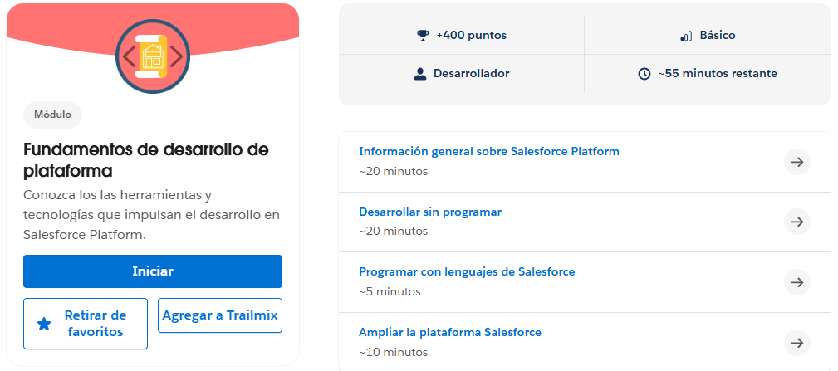

**2.1.** [**Información general sobre Salesforce Platform**](https://trailhead.salesforce.com/es/content/learn/modules/platform-development-basics/get-started-with-the-salesforce-platform-01?trail_id=explore-core-salesforce-developer-responsibilities)

**2.2.** [**Desarrollar sin programar**](https://trailhead.salesforce.com/es/content/learn/modules/platform-development-basics/develop-without-code-01?trail_id=explore-core-salesforce-developer-responsibilities)

**2.3.** [**Programar con lenguajes de Salesforce**](https://trailhead.salesforce.com/es/content/learn/modules/platform-development-basics/code-with-salesforce-languages-01?trail_id=explore-core-salesforce-developer-responsibilities)

**2.4.** [**Ampliar la plataforma Salesforce**](https://trailhead.salesforce.com/es/content/learn/modules/platform-development-basics/extend-the-salesforce-platform-01?trail_id=explore-core-salesforce-developer-responsibilities)